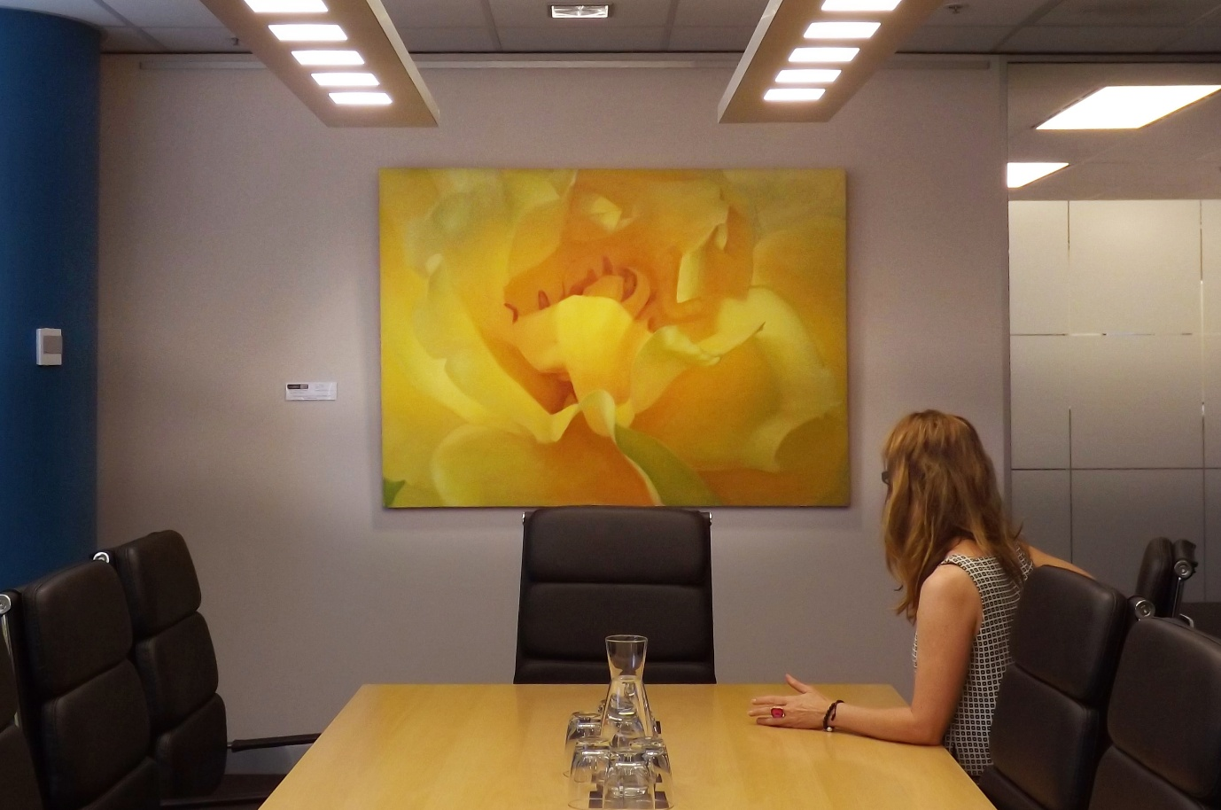

Smart, Flexible Wall Solutions for Offices
Design with real people in mind
When fitting out an office after a new build or renovation, it's worth thinking ahead:
How will the space be used? What needs to go on the walls? And how can we keep things looking great without patching and painting every few months?
That’s where a good picture rail system comes in. It lets you hang whiteboards, artworks, staff awards or signage—without damaging walls. You drill once, and then you’re free to move things around as needed.
It’s simple. And it works.
A picture rail gives you the freedom to adapt the space to the people who use it. Whether you're rotating branding, updating displays, or refreshing the energy in a meeting room, it makes change easy.
And the system stays quietly in the background, letting your content take centre stage.
From a sustainability point of view, it’s smart too. One installation means less waste, fewer repairs, and longer-lasting finishes. You’re not just hanging something—you’re protecting your space for the long term.
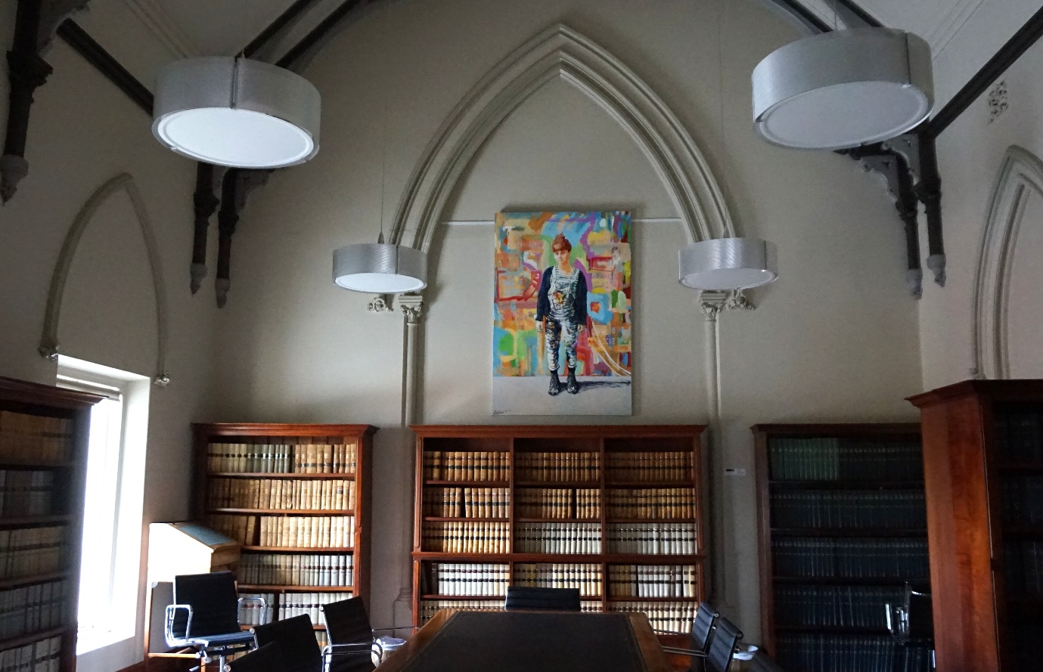

Not sure which picture rail to choose?
Here’s how to figure it out.
First things first: can the rail go on the wall, or does it need to go on the ceiling?
If you're renovating and the walls or ceilings are already finished, the Click Rail is usually your best bet. It mounts directly onto the wall just under the ceiling. If you’re working with a recessed ceiling, go for the Top Rail, which attaches to the ceiling’s edge trim and stays neatly out of sight.
If it’s a new build, you’ve got even more options. Integrated rails—like our Shadowline systems—can be built straight into the walls or ceiling lines while the plasterboard is going up. It’s a smart move if you're thinking long-term: no damage to walls, full flexibility for future changes, and a clean, minimal look from day one.
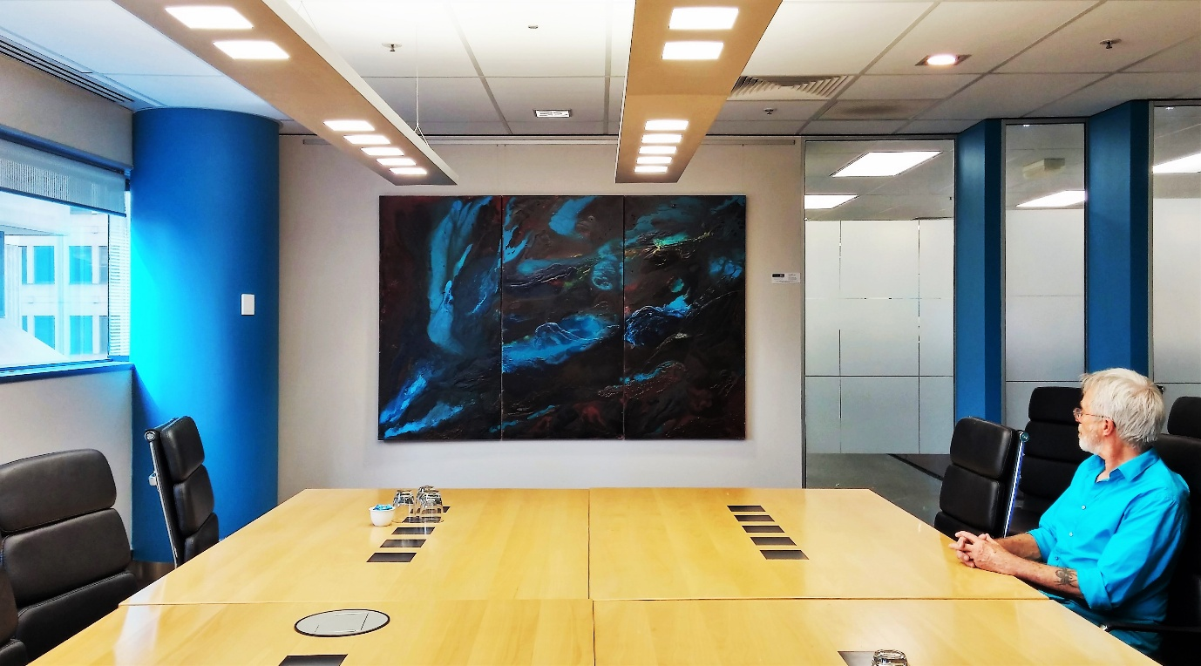
What about wires and hooks?
It depends on the weight of what you're hanging.
You’ve got two main types of hanging wire:
• Perlon, a clear wire that’s almost invisible on the wall
• Steel, stronger and ideal for heavier pieces
Both come in 1 mm and 2 mm thickness. The heavier the artwork, the thicker the wire you'll need.
Hooks also come in different styles and capacities. Some lock manually, others auto-grip (like the Micro Grip), and each has its own weight rating—from 4 kg up to 20 kg per hook. You just need to match the right hook to the weight of your piece and the type of wire you're using.
And here’s a good rule of thumb:
Always use two hooks and two wires per frame. It’s more stable and stops the artwork from shifting sideways.
How much weight can the rails hold?
Rail type | Max weight per metre
Click Rail | 30 kg
Click Rail Pro | 50 kg
Top Rail | 20 kg
Just make sure you’ve got the right combination of rail, wire and hook, and you’re good to go.
If you're still unsure, call us on 0432 924 305 and we’ll help you work it out.
